**Activity 2**

1. The aim of this exercise is to create two charts, and get choices you make in one to influence the other by import the data from “Exercise1-1.csv” into Power BI.

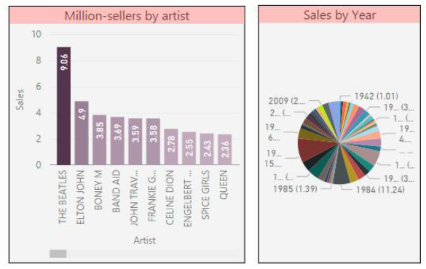

2. By using the Excel file “Exercise1-2.xls”, create a new Power BI report for getting a list of the FTSE 100 shares with picture.

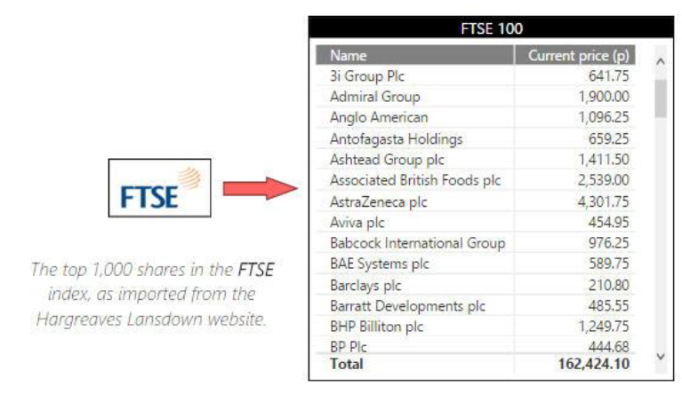

* 1. 3. Imagine you’re retiring in U.S. –you want to live where there’s lots of sunshine, low crime rates, and good health care –or perhaps you’re a data analyst, and you want that information to help your customers. For example, maybe you want to help your sunglasses retailer target sales where the sun shines most frequently. A) Obtain the best and worst states for retirement from the following website:

http://www.bankrate.com/retirement/best and worst states for retirement/

* 1. B) Obtain the List of U.S. state abbreviations from the following website:
     1. C) Create a Power BI report with the following information:
     2. i. Overall Rank by State Code
     3. ii. Overall Rank, Health Care Quantity and Well-being by State
     4. iii. Cost of Living, Overall Rank, and Weather by State

